# Install MySQL server on client machine

# Extract Database

1. Open MySQL workbench
2. Open data export from Server -> Data Export
3. Choose options as shown in the following screenshot:

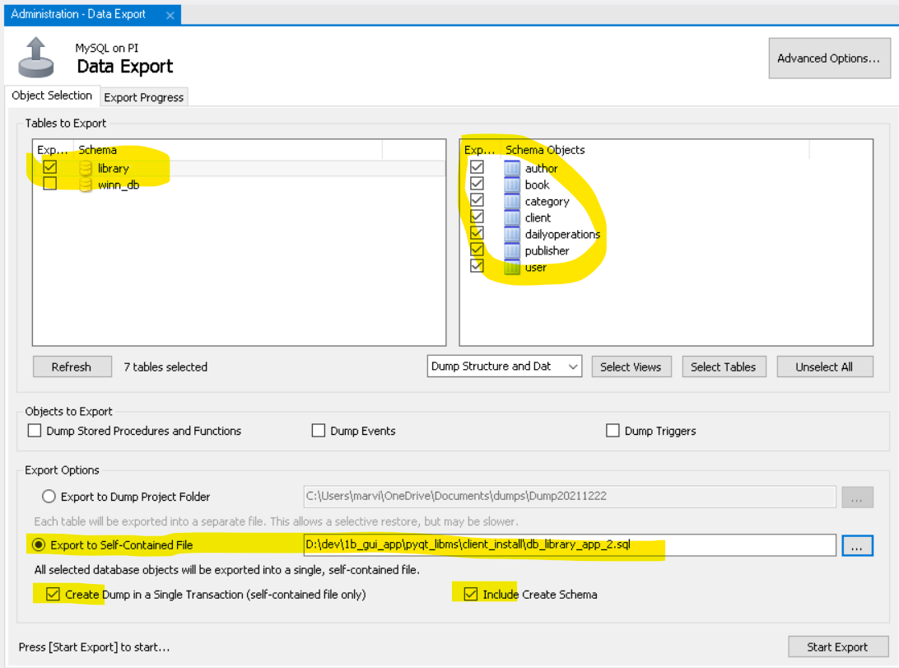

1. Open MySQL workbench on the client machine:
2. Open a tab by Query -> New Tab to Current Server
3. Copy and paste the statements from the exported file in Step 3.
4. Run the statements to create database ‘library’ and associated tables.

(3) Convert to exe:

Using cx-Freeze 6.9 to Create standalone executables from Python scripts

[Using cx_Freeze — cx_Freeze 6.9 documentation (cx-freeze.readthedocs.io)](https://cx-freeze.readthedocs.io/en/latest/overview.html)

1. Run >Pyuic6 library.ui -o library.py
2. Run >pyuic6 login.ui -o login.py
3. Create a new folder named: pyqt_libms_deploy
4. Copy all files from pyqt_libms to pyqt_libms_deploy
5. Change to pyqt_libms_deploy, and removed files that are not needed
6. Activate the venv
7. Install cx-Freeze 6.9 by running pip install cx-Freeze
8. Run cxfreexe-quickstart

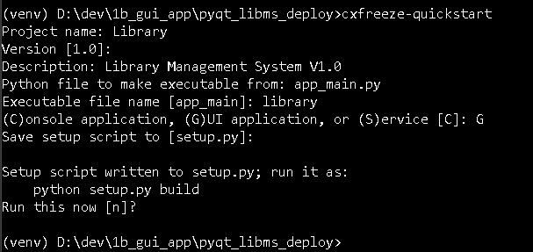

1. Edit the generated setup.py file

from cx_Freeze import setup, Executable

# Dependencies are automatically detected, but it might need

# fine tuning.

build_options = {

'packages': [],

'excludes': ['tkinter' ],

'include_files': ['themes', 'img', 'library.py', 'login.py', 'utils.py', '.env']

}

import sys

base = 'Win32GUI' if sys.platform=='win32' else None

executables = [

Executable('app_main.py', base=base, target_name = 'library')

]

#include_files = ['themes', 'img', 'library.py', 'login.py', 'utils.py', '.env']

setup(

name='Library',

version = '1.0',

description = 'Library Management System V1.0',

options = {'build_exe': build_options},

# options = {'build_exe': {'include_files': include_files}},

executables = executables

)

1. Run >python setup.py build